# **User Documentation – Password Strength Tester**

User-friendly guide / user manual, explaining how to use the password strength tester program.

* Step 1: Open a terminal and locate the folder that you have the python application saved in.

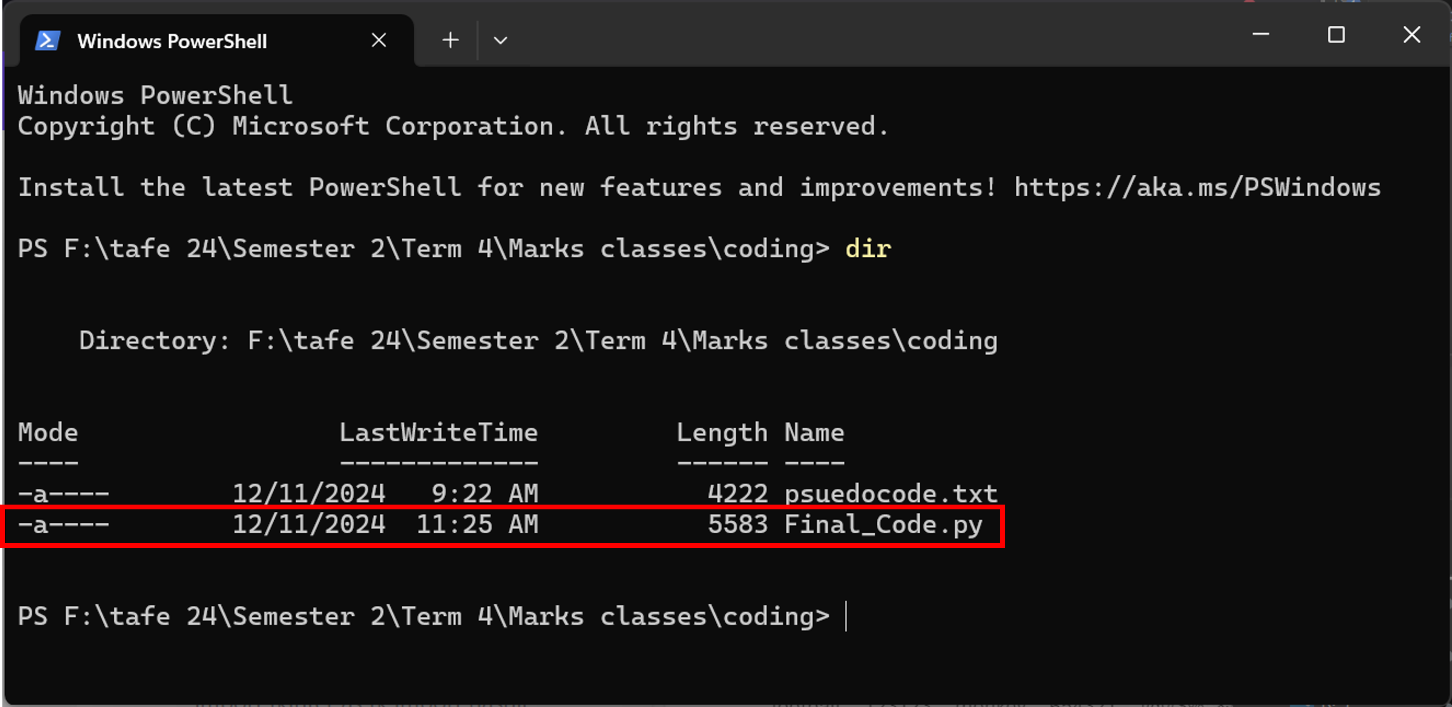

* Step 2: Use the python command to run the application

Inserting image...

* Step 3: Once the code had been run the password tester application or a page will open

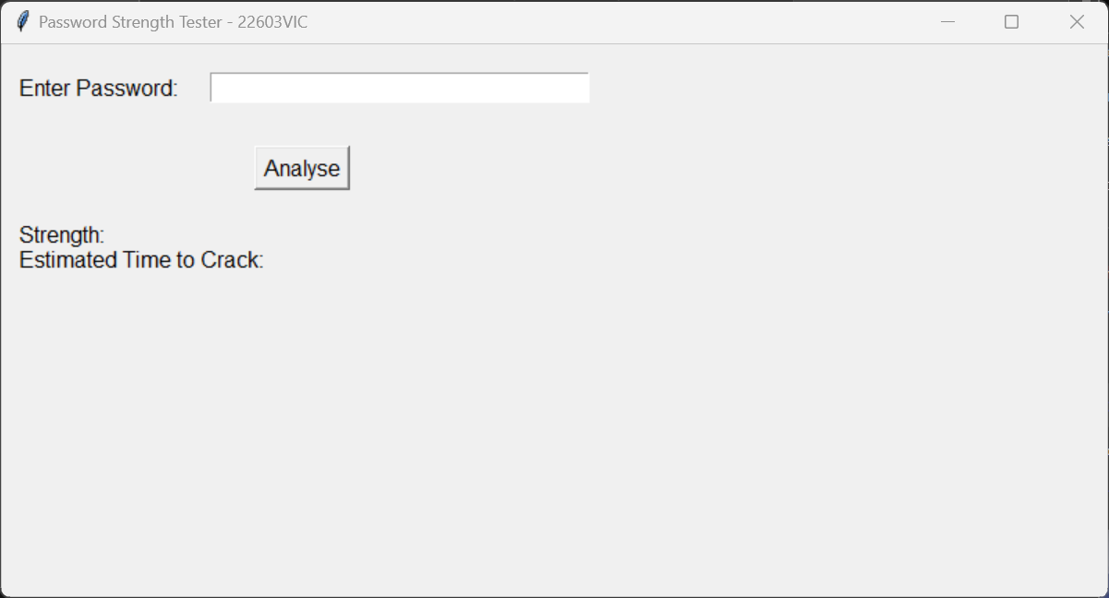

* Step 4: Enter the password you want to test into the input box and click ‘Analyse’ to test it. (for this test “Password1” was used.

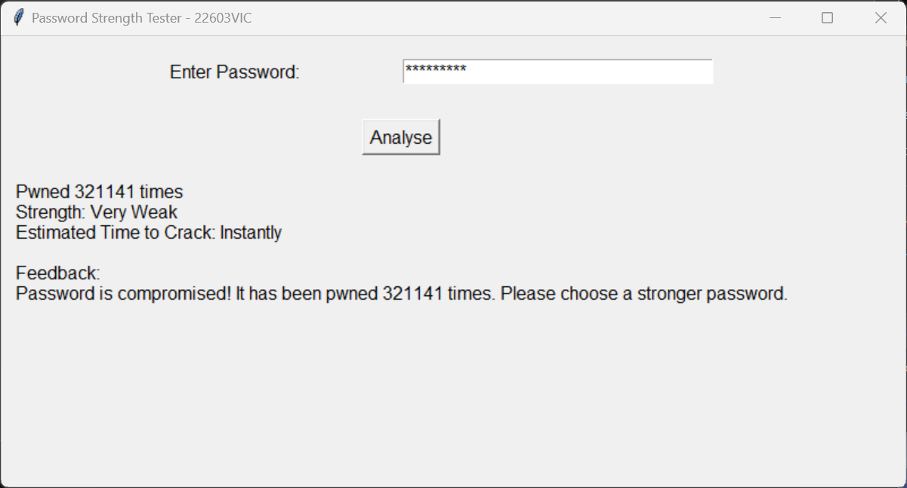

* Step 5: See your results for how strong your password is and act accordingly.
* Step 6: if the password is compromised it will tell you how many times it has been compromised
* Step 7: The program will give you suggestions on how to improve your password based on what you input, for example, add upper case, add numbers, etc.